**DAILY ONLINE ACTIVITIES SUMMARY**

|  |  |  |  |  |  |  |  |
| --- | --- | --- | --- | --- | --- | --- | --- |
| **Date:** | **25/05/2020** | | | | **Name:** | **Varsha H Shetty** | |
| **Sem & Sec** | **8th B** | | | | **USN:** | **4AL16CS117** | |
| **Online Test Summary** | | | | | | | |
| **Subject** | | **No test** | | | | | |
| **Max. Marks** | | **No test** | | **Score** | | **No test** | |
| **Certification Course Summary** | | | | | | | |
| **Course** | AWS lambda foundations | | | | | | |
| **Certificate Provider** | | | **AWS** | **Duration** | | | **60 min** |
| **Coding Challenges** | | | | | | | |
| **Problem Statement::** | | | | | | | |
| **Status: COMPLETED** | | | | | | | |
| **Uploaded the report in Github** | | | | **YES** | | | |
| **If yes Repository name** | | | | **Varsha-Shetty** | | | |
| **Uploaded the report in slack** | | | | **YES** | | | |

Online Test Details:

Certification Course Details:

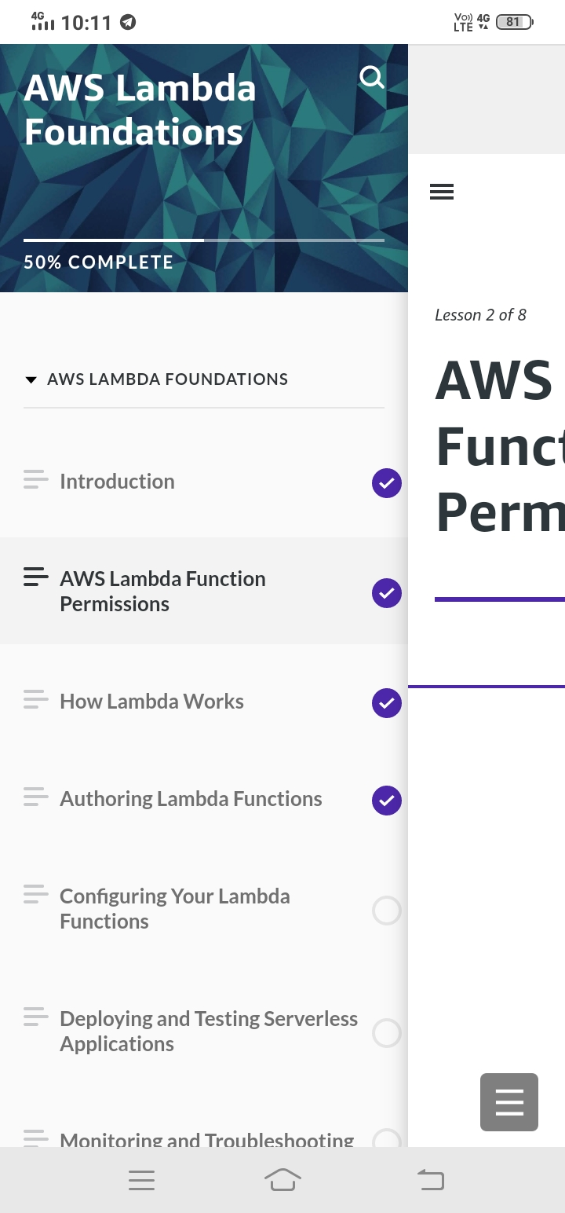

## AWS lambda foundations

Coding Challenges Details

class Solution {

public int missingNumber(int[] nums) {

Set<Integer> numSet = new HashSet<Integer>();

for (int num : nums) numSet.add(num);

int expectedNumCount = nums.length + 1;

for (int number = 0; number < expectedNumCount; number++) {

if (!numSet.contains(number)) {

return number;

}

}

return -1;

}

}